***Philadelphia Federation of Teachers Health & Welfare Fund***



1816 Chestnut Street Philadelphia, PA 19103

215/561-2722 Fax: Fax: 215/5618345

www,pfthw.org

**Indoor Environmental Quality [IEQ] Evaluation**

**at the**

**Webster E.S.**



Jerry Roseman M.Sc. IH, OHCS, Inc.

Director of Environmental Science & Occupational Health & Safety for the Philadelphia Federation of Teachers Health & Welfare Fund & Union [PFTH&WF/U-H&S]

Evaluation Dates: January 6 & 7, 2016

Summary

Our investigation on 01/06/2016 revealed significant building condition-IEQ-related deficiencies, in addition to educational programming & occupant health impacts:

1. ***Major water damage associated with ruptured heating system piping in 7 classroom areas;***
2. ***Dirty, rusted & deteriorated classroom unit ventilators [CUVs] and air filters were observed;***
3. ***Extremely cold temperatures were measured in, and reported for normally occupied spaces, including stairwells & hallways;***
4. ***Staff & students had to be relocated from 7 instructional spaces impacting educational programming;***
5. ***HVAC system components have repeatedly been documented as inadequate in their operation & ability to provide acceptable air quality & thermal control & indoor air quality concerns, & water, dampness, moisture & mold have been long-standing problems.***
6. ***Water damaged and stained building materials including ceilings, floor tile and cork boards were documented;***
7. ***Limited resources were initially devoted by the SDP to address the lack of heat following the rupture of CUV piping;***
8. ***As of our 1/7/2016 follow-up visit, heat had been restored to a number of areas and general/overall improvement had been achieved and was ongoing with further work required.***

This report reflects currently available information and status as of 1/8/2016 – if further data is provided by the SDP we will amend the report accordingly.

On January 5, 2016, PFTH&WF/U-H&S was notified about a major flooding event that had occurred at Webster E.S. impacting at least 5 occupied classrooms and adjacent educational spaces, requiring an IEQ-related evaluation to be conducted.

On 1/6/2016, environmental science inspectors from the PFTH&WF/U-H&S and SDP-OEMS conducted a joint observational site visit. We spoke with the school building engineer & principal and about a dozen teachers. We also conducted a targeted, limited inspection of impacted areas:

* Flood-impacted rooms 101, 102, 103, IMC, 200, 205 & 305
* Experiencing extremely cold temperatures were Autistic and Emotional Therapeutic Support Rooms, the Reading-Resource Room, and stairwells and hallways.

We documented conditions present at the time of our visit by taking photographs and by measuring temperatures in some areas. We found direct evidence of:

* Dirty, rusted and failing ventilation system components;
* Major water damage to building materials including asbestos floor tiles in some areas; and
* Numerous educational spaces without any heat and others with inadequate heating resulting in excessively cold temperatures;
* Staff & students wearing and reporting the need to routinely wear coats, hats and gloves in normally occupied educational spaces;

Given that the flooding event had occurred at about 11 am on 1/5/16, heat should have been restored to educational spaces before the start of the next school day and/or consideration given to closing the school because of the excessively cold temperatures in multiple building areas requiring relocation.

Our follow-up evaluation on 1/7/2016 documented improvements in overall thermal control in several areas including in rooms 101, 102, 103, & the IMC with further evaluation and remediation still required. We also observed exterior doors being kept open for extended periods of time [10-20 minutes or more] resulting in difficulties in achieving proper heating in some areas.

It is worth noting that there have been multiple IEQ and/or building condition assessments and evaluations conducted at Webster over the past 6 years, all of which have documented the same type of problems described in this report. Inspections have been conducted by SDP environmental consultants and/or contractors, as well as jointly with PFTH&WF/U-H&S. The most recent comprehensive inspection is the Facility Condition Assessment conducted [2015-2016] at this school. Additionally, SDP Maintenance, Operations, Capital Program Office and OEMS have all been involved in assessments and evaluations at this site, and all of which have documented significant issues with ventilation, air quality and thermal control.

Background

Webster E.S. is a 3 story K-5 E.S. located at 3400 Frankford Ave. and constructed in 1968. In addition to the main building there is also a Little School House [LSH]. There are approximately 900 students enrolled at the school and a total of about 90 educational, administrative, building engineering/custodial, and support staff. The school principal is Christopher Byrd and the current building engineer is William Smith. Scott Ovington is the FAC. Approximately 80% of the students at Webster are either African American or Hispanic/Latino.

The 11062015 IEQ Dashboard Master [the most recent one provided to us the by PSD-OEMS] included findings from some previous [not all] inspections from the past 6 years identifying a total of forty two [42] deficient items only one [1] of which is listed as “open.” Despite information included on the current IEQ Dashboard the current scale, scope, and extent of deficiencies at Webster is greater than what is listed.

A very abbreviated summary of some of previously conducted evaluations and conclusion are provided below:

* In December of 2009, the then Sr. VP of CPO, the COO for the District, and the Sr. VP for FMS were informed about inspection results documenting;
  + Ongoing and reoccurring failures in the school piping and HVAC systems;
  + Lack of heat and/or cooling and deficient amounts and distribution of fresh air;
  + Filthy HVAC system filters and components including rodent droppings inside and on top of, ventilation systems;
  + Sealing of fresh air intakes as a money-saving device and to “protect” the HVAC equipment from catastrophic failure;
  + Filthy HVAC system filters and components including rodent droppings inside, and on top of, ventilation systems
* On December, 22 2009, the SDP’s Regional Facilities Maintenance Manager for the Northeast Facilities wrote the following:

“The air compressor which controls the thermostat system is in need of major over haul or replacement. It has been determined that the many air leaks throughout the building has caused the malfunction of the pneumatic system. The main office thermostat has been replaced to [try] and control the overheating, however with the many leaks throughout the building it may not be effective.”

* Also in 2009 the SDP FMS Department listed Webster as a “Top Ten” for Capital Improvement for work to address the HVAC-related moisture, mold, dampness and thermal control issues – this work was never conducted;
* In 2010, the SDP hired Synertech Environmental to follow-up on reported conditions and they noted in their 1/7/2010 report that “based on previous studies and the visual observations of water staining and rusted ceiling tile tracks in the building it is clear that moisture issues in the Webster Elementary School have persisted for some time. ***Site visits have been conducted and reports have been prepared by Synertech Incorporated in the past to address some of the same issues addressed in this report.” [emphasis added]***.
* Other consultants [KEM & 1-Source] to SDP-OEMS also looked at Webster in September of 2010 creating a detailed report with 603 noted findings concluding that more that 50% of them were “items which can negatively impact indoor environmental quality or are indicators of negative impacts.”
* In 2011 and 2012, the CPO conducted evaluations and assessments of the school’s HVAC system components;
* Between 2012 and 2016 additional multiple site visits have continued to be conducted at Webster E.S.

Discussion & Recommendations

The conditions reported, observed, and documented at Webster ES related to the rupture of heating pipe equipment and excessively cold temperatures in other building areas require[d] urgent and ongoing attention. The problems existing at Webster also highlight serious systemic concerns related to:

• Comprehensive and coordinated evaluation and documentation of all recognized deficient building conditions;;

• Lack of complete school “profile” information related to building and mechanical system conditions, problems, issues and recommended operating and management recommendations and guidelines; and

• The consequences associated with a too limited commitment of necessary resources, sufficient to ensure remedial measures are implemented in a timely and effective manner.

**1) Information Limitations**

As discussed above, extensive information and data is available about the deficient HVAC system conditions at Webster E.S. but much of that information was not generally or readily available at the school. Data about the previously documented problems with system components and thermal control might have been useful in helping to prevent the heating pipe freeze-up and related problems that occurred.

Work order system details and status, findings, observations, notes and recommendations from the 2015-2015 Facility Condition Assessment, and other building condition/system information and data, should have been available at the school; the lack of access to this type of documentation, compromises effective preventive actions from being taken to help ensure Safe, Dry, Warm & Comfortable buildings.

**2) SDP Resource Limitations** **For Remediation**

From a short-term response perspective, following the rupturing of heating pipes in 7 rooms and the loss of all heat to those areas on 1/5/2016, compounded by very cold temperatures in an additional 6+ educational spaces/classrooms including both Autistic Support and Emotional Support classrooms, a more robust and immediate response than the one implemented on 1/5/2016 through the afternoon of 1/6/2016 would have been advisable.

Reportedly, only two [2] mechanics were on site on 1/6/2016 [during our inspection] and all impacted rooms and areas, as well as numerous other spaces, had been without any and/or sufficient heat since the beginning of the week. High level contact by representatives of the PFT to SDP management was required to facilitate an upgraded response beginning in the mid-late afternoon on 1/6.

Highlighting thermal deficiencies in the school, several teachers were observed to be wearing coats in classroom areas. One of the teachers on the 1st floor had placed a portable heater in her room because of the very cold conditions [temperature in her room during out inspection was 540F]. The classroom teacher stated that in order to stay warm, “we have to wear coats, hats, jackets, everything.” Another teacher reported that the cold temperatures in the school are typical at Webster in many rooms and areas and have been like that for a number of years. She said that the classrooms are extremely cold “until around mid-week and that at least twice a week, usually on Monday and Tuesday, it’s a definite that they need outerwear” and that she has “hoodies and things for the kids if they don’t have their own.”

**3) Prioritizing & Implementing Capital Improvements & Ensuring Ongoing Maintenance Management & Control**

The building condition-IEQ problems at Webster have been ongoing and well-documented for at least the past 6 years and likely much longer. Approximately five [5] years ago the Maintenance Department recommended major re-piping work be conducted and multiple evaluations have demonstrated the negative impacts of the existing conditions on school occupant health, on fiscally sustainable cost and on educational and academic programming. It is unclear exactly what work has been done at this school over the years and why necessary capital improvements have not yet been implemented.

In addition to resolving the root cause issues associated with the school HVAC and thermal control systems [almost certainly a capital effort], short and medium term ongoing fixes are required in order to protect occupants, control costs, safeguard educational materials and promote academic programming.

**4) Need for Comprehensive Evaluation & Review & Implementation of an Operations & Maintenance Plan**

Based on the 1/6/2016 inspection at Webster, and on discussions with FMS & OEMS representatives as well as a review of previous reports, dashboards, findings, and recommendations, it is critical that an overarching and comprehensive review and status of building system equipment, operation and status be immediately undertaken. Issues with HVAC system control valves, dampers, convectors, piping, fresh air distribution, and thermal control system components have all so far been documented and associated with the 1/5/2016 heating pipe rupture/flooding event. In addition, staff consistently reported that widespread thermal control issues have existed for many years.

An example of why it is especially and urgently necessary now to assemble a comprehensive evaluation and ongoing Maintenance and Operations Plan for addressing problems at Webster is provided by taking a closer look at what happened on 1/5 and 1/6.

It is known that many of the CUVs have been, and are, improperly functioning in a variety of ways. One of the most meaningful issues, particularly related to the ruptured heating pipes, is the fact that outside air [intake] dampers often don’t operate properly and are either completely sealed from the outside [using plexiglass sheets] thereby restricting all fresh air from being introduced into educational spaces, or else the dampers are “locked” into a substantially fully opened position, resulting in outside air, at whatever the current temperature is, streaming into the building interior, through and past the CUV dampers, water piping and coils. When this second condition occurs, and if outside air temperatures are sufficiently cold, heating pipes can easily freeze and burst.

During the period 1/3/2016 – 1/7/2016 temperatures were in the range of 120F – 400F, with early morning and evening temperatures typically less than 200F.

At the same time, and apparently in an effort to control costs, the school heating system was not being operated in the evenings prior to Monday, 1/4/2016 [we were informed that last year, when there were no ruptured pipes reported, the school heating system was being operated during off hours to address this issue]. The very cold outdoor temperatures, associated with the failure to operate the heating system and the overall deteriorated HVAC system conditions [including lack of insulation around/on some components] is what resulted in the problems experienced during the week of 1/4/2016.

The problems that occurred were preventable and could have easily been avoided by closer monitoring of the situation and HVAC system conditions, applying proper control measures [including running heat during periods of non-occupancy, frequently inspecting HVAC function, operation and condition, ensuring adequate insulation of exposed piping, and not permitting outside are dampers to be fully open in extreme cold weather conditions].

**The following interim recommendations are being provided [we assume that in addition to work that has by now been conducted, recommendations will also be provided by OEMS, FMS, and CPO]:**

1) Immediately ensure that all school areas are adequately heated [and without excessive thermal conditions];

2) Ensure all heating and thermal control system problems are “inventoried”, fully described and documented;

3) Identify all necessary short, medium and long-term repair and remediation needs, with associated work scopes and time frame/scheduling details. This should be done jointly to include PFTH&WF/U-H&S representatives;

4) Gather together all existing information, and data related to the HVAC and thermal control system equipment, condition, operational status & operational management. This should include, but not be limited to: [a] previous environmental assessment reports, dashboards, DDCs, and other data; [b] relevant work order history and maintenance summaries; [c] 2003-2005 Facility Condition Assessment findings; [d] 2015-2016 Facility Condition Assessment findings; and [e] occupant-provided information;

5) Develop a detailed, written Operations & Maintenance Plan and guidance document to be used at/for Webster E.S.

6) Immediately provide & share the above information & data with PFTH&WF/U-H&S & other relevant stakeholders;

7) Coordinate, schedule and conduct joint follow-up assessment and evaluation activities to facilitate verification and accountability of recommended implementation; and

8) Establish an Environmental Action Team to meet during the week of January 18, 2016

PHOTOS

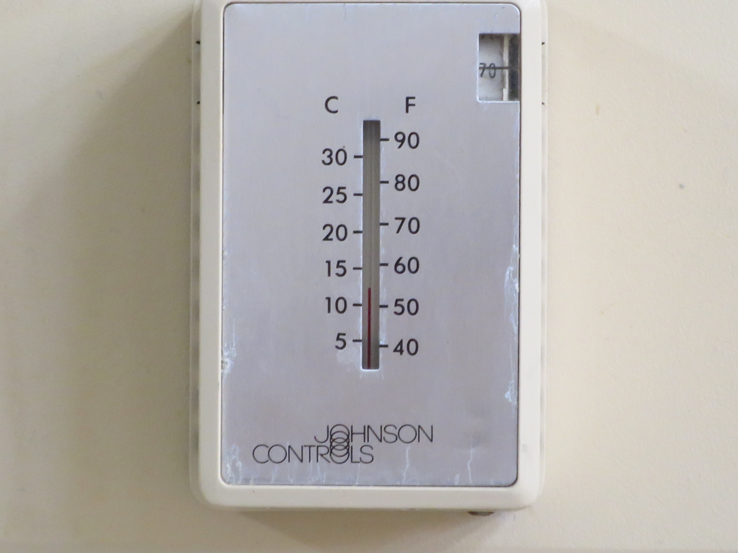

**Photo 1: Webster E.S. – 01.06.2016 – Classroom 110 – This room was NOT impacted by flooding but was very cold – room thermostat measures about 550F**

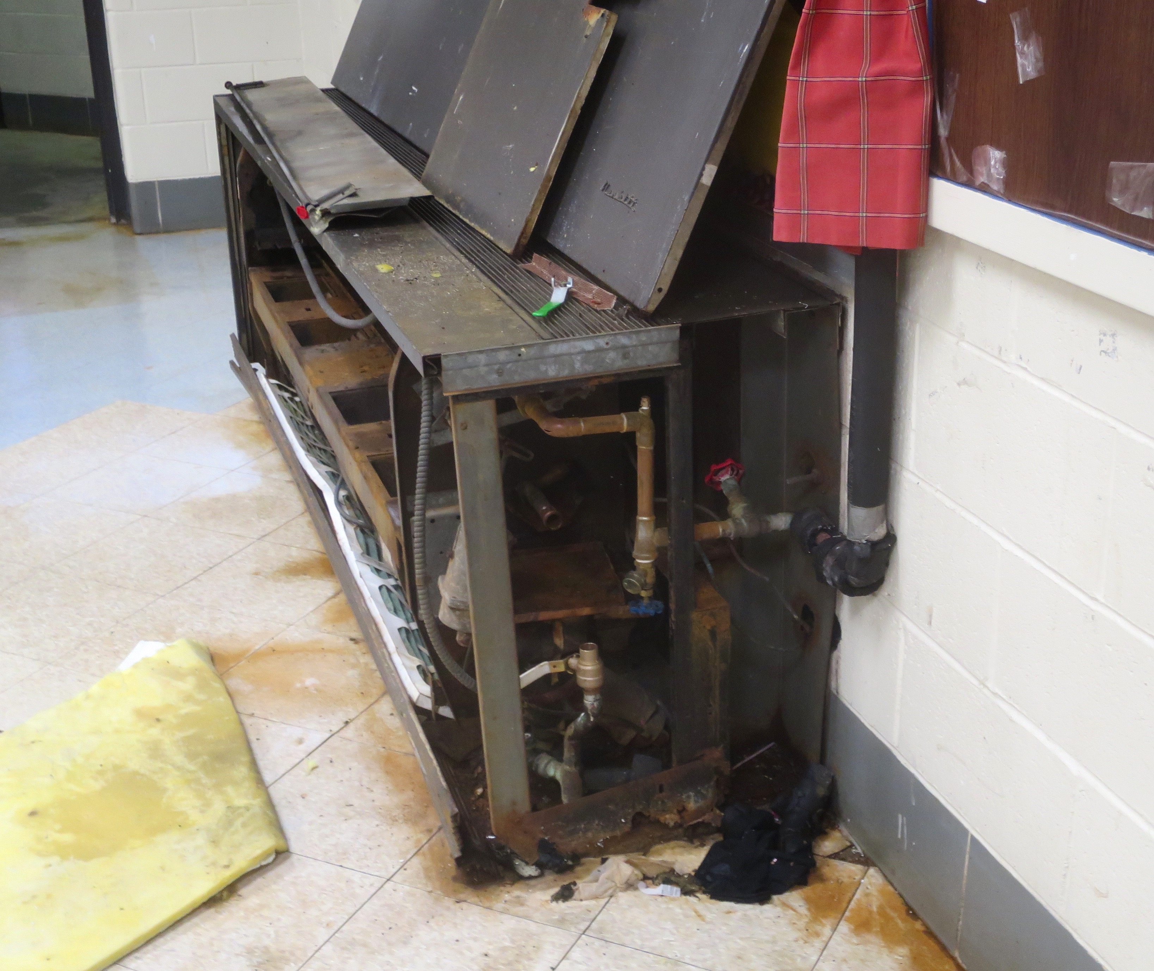

**Photo 2: Webster E.S. – 01.06.2016 – Classroom 101 – Water damage to floor**

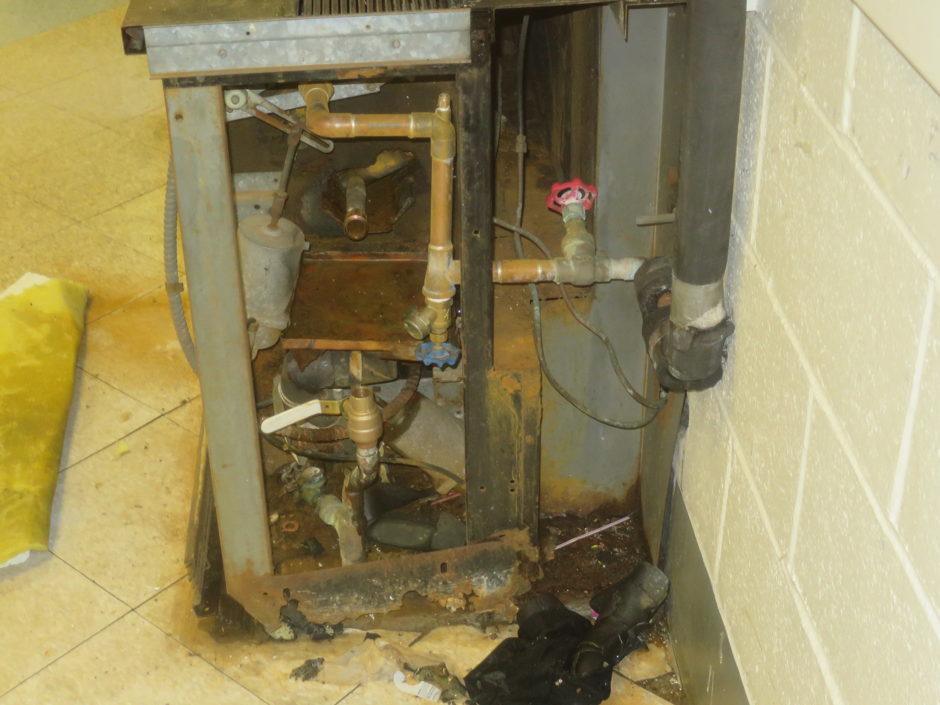

**Photo 3: Webster E.S. – 01.06.2016 – Classroom 101 – Dirty, Rusted CUV condition**

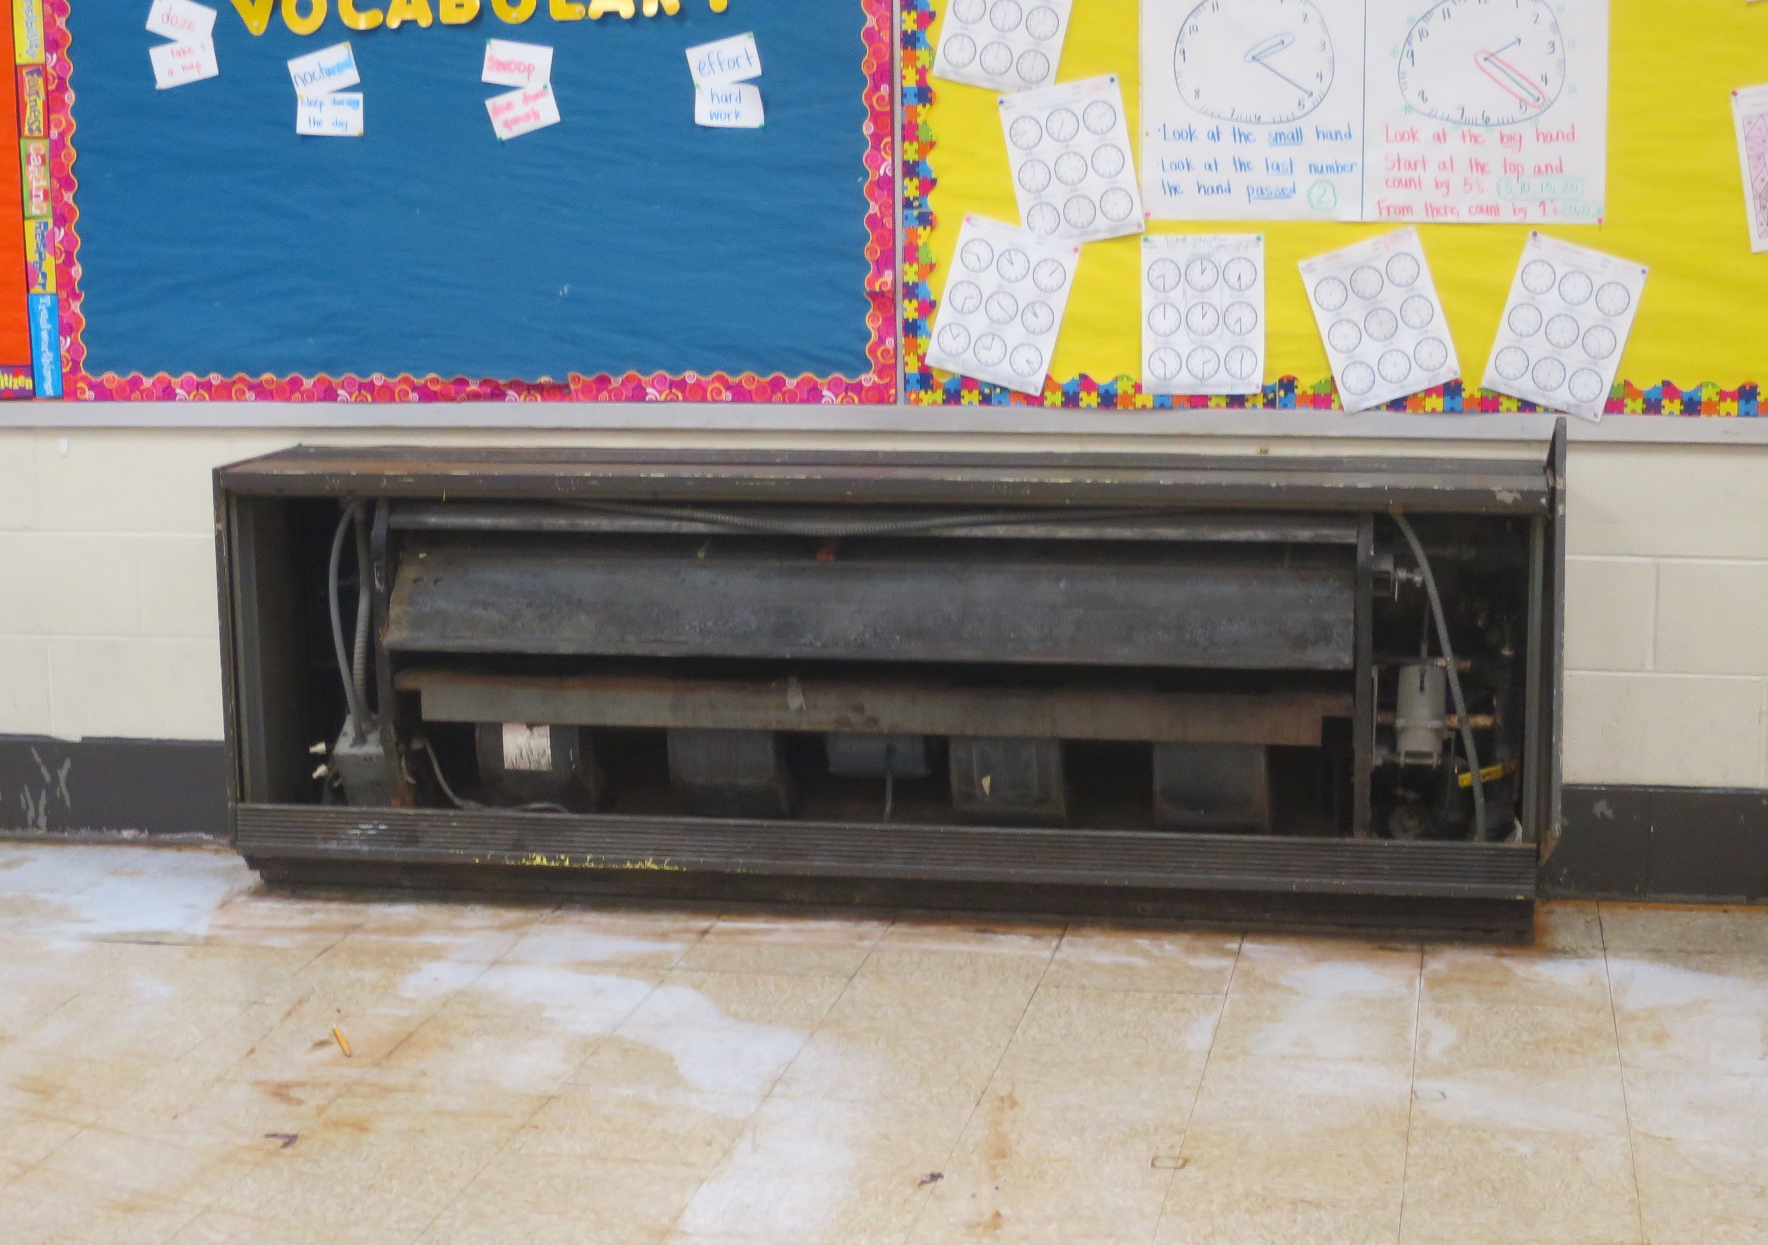

**Photo 4: Webster E.S. – 01.06.2016 – Room 205 – CUV – Flood Damage to Floor**

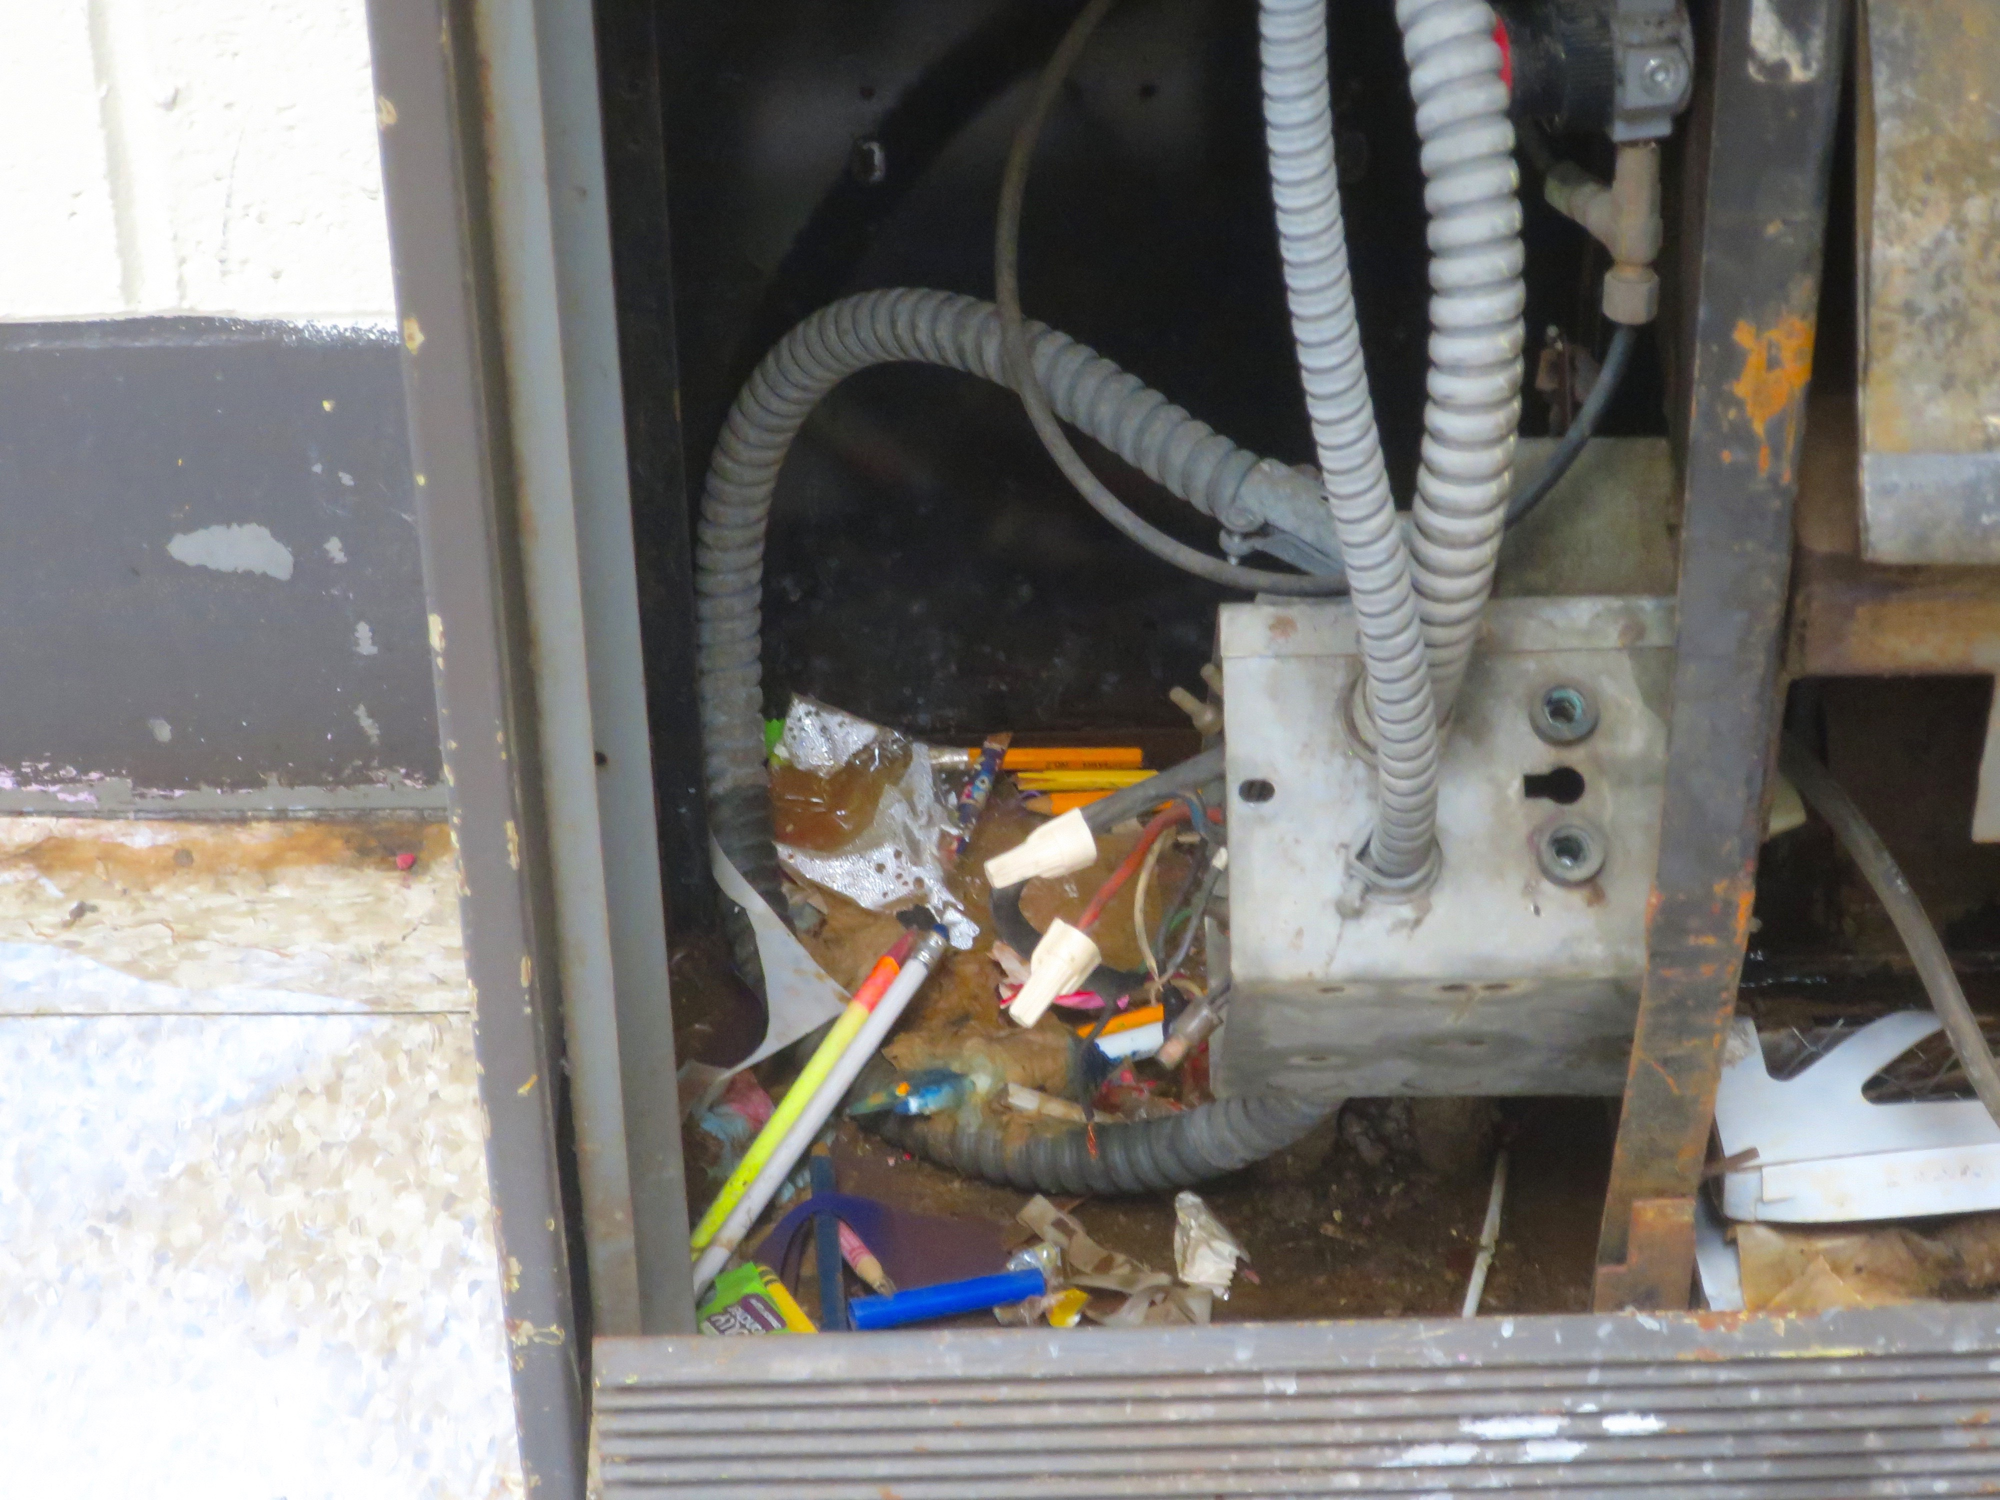

**Photo 5: Webster E.S. – 01.06.2016 – Room 205 – CUV – Close-Up – Interior Damage Condition**

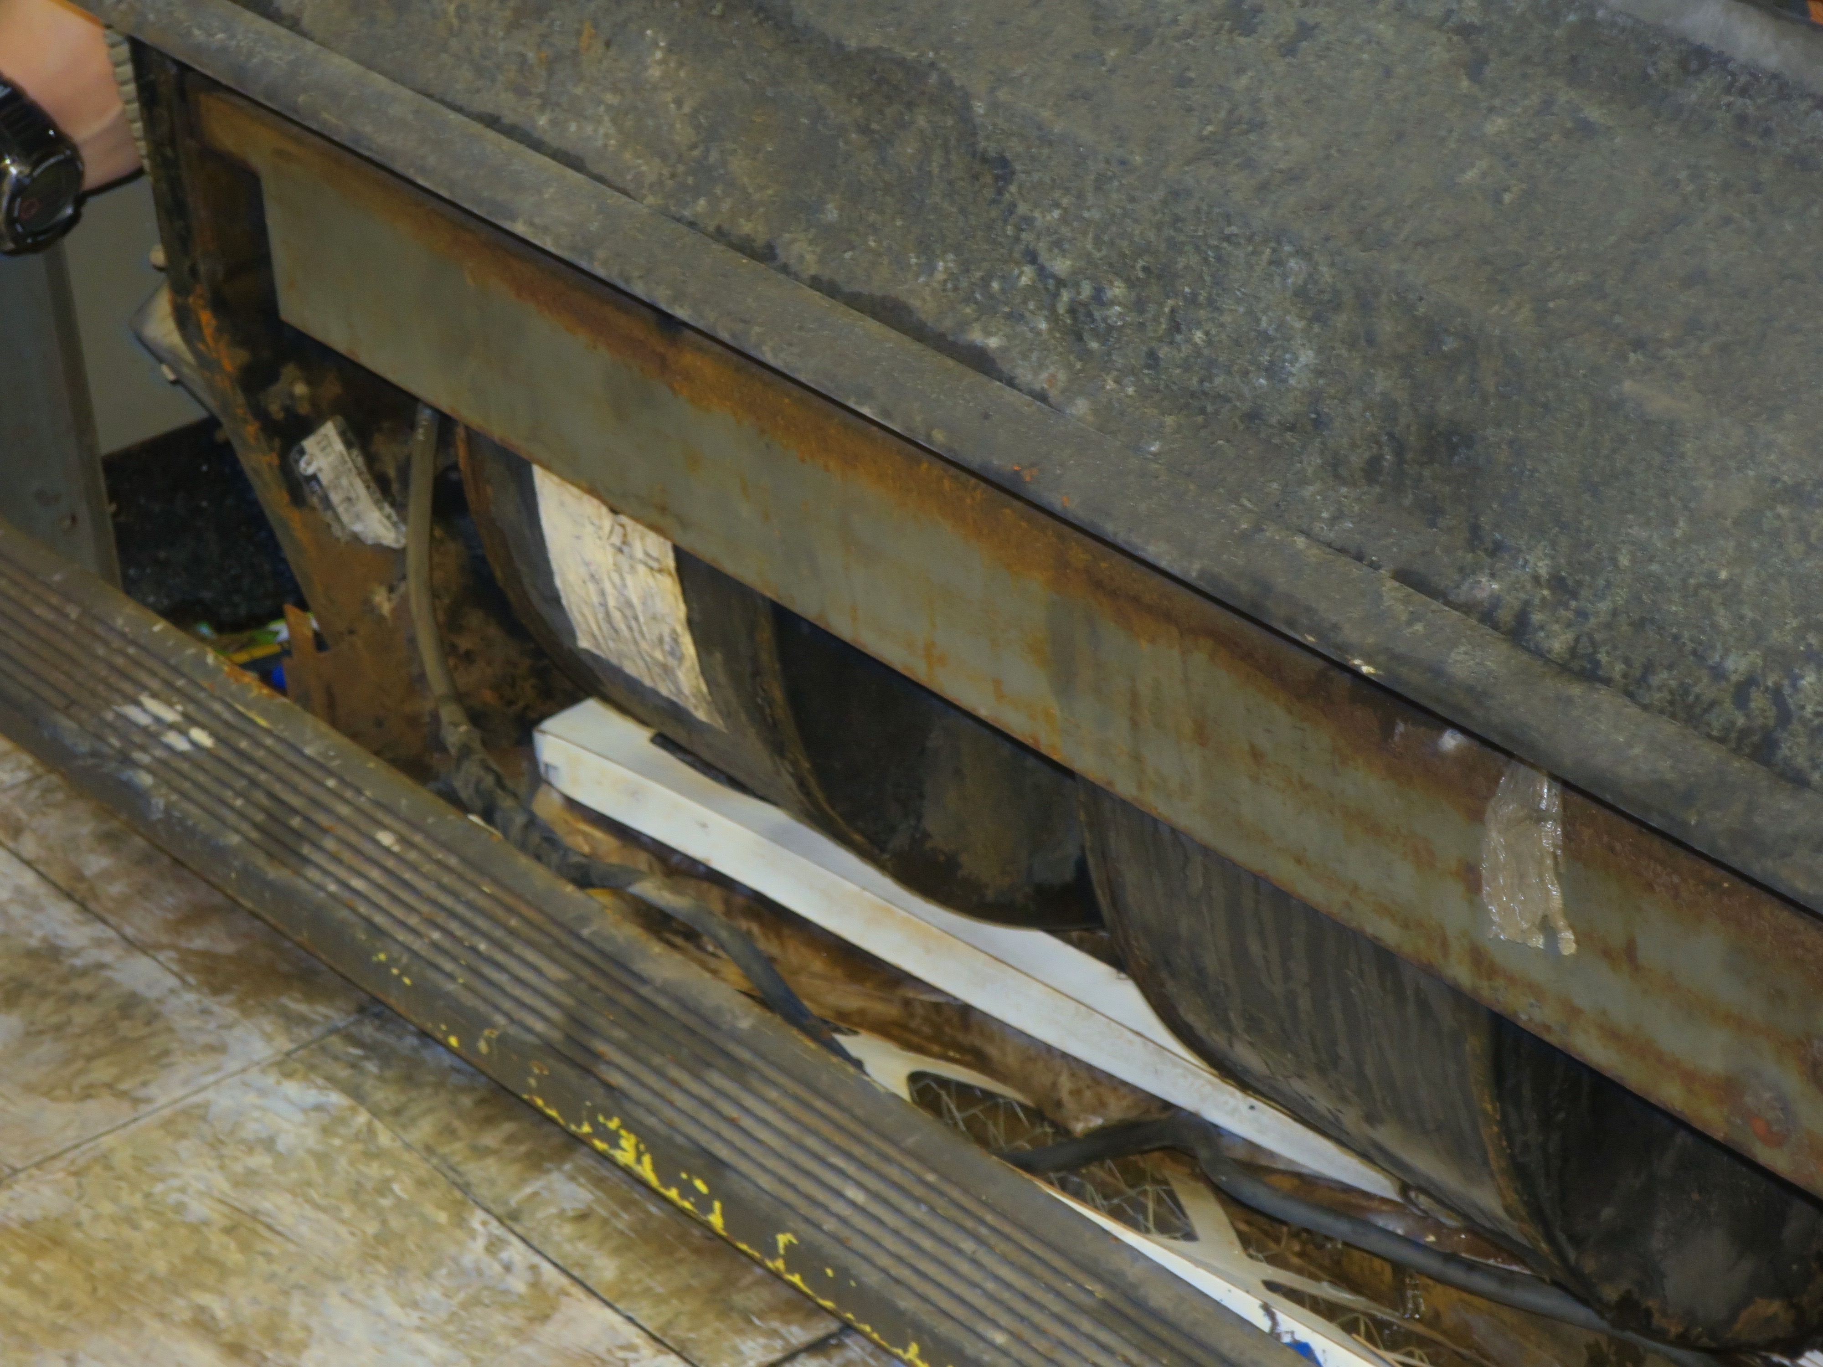

**Photo 6: Webster E.S. – 01.06.2016 – Room 205 – CUV – Inadequate Filters**